Thomaston Townwide PTA
2021 - 2022
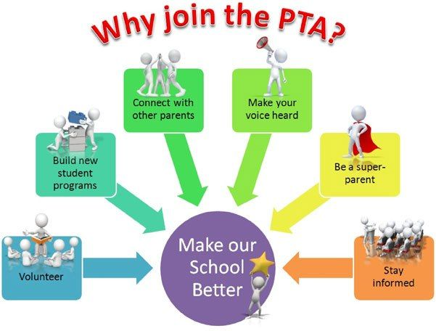

The Thomaston Townwide PTA is asking for your support. Fees are $10 for a Single Adult Membership. Parents, relatives, students and teachers are welcome to join.

Please make your check payable to “Thomaston Townwide PTA.” You may return this form, along with your payment, to the school office.
Thank you for your support!
PTA does accept payments via Venmo. Our Venmo username is: Thomaston-PTA
www.venmo.com/u/Thomaston-PTA

Quantity of  Single Adult Memberships | $10 each | Total Payment
________ | X $ 10.00 | = $________
Check Cash Venmo
Student(s) Name(s) _____________________________________ Grade(s) ____________
Member(s) Name(s) ________________________________________________________
Address: ________________________________________________________________
Phone #_______________ E-mail Address_____________________________________
Please check the appropriate box(es):
Parent(s) Administrator Teacher Staff

